##### Data Product: Completion

**Unit Testing:** Unit testing individual functions (e.g., calculations, data parsing), focuses on verifying individual functions related to data processing. Here's a detailed explanation of how the testing was performed and the interpretation of the outcomes:

1. Setup and Framework: The unit tests were written using Python’s unittest framework, which provides a rich set of tools to assert conditions and manage test preconditions and cleanups using setup and teardown methods.
2. Test Cases: Specific test functions were defined to test different aspects of the load_and_process_data function within my application:
   1. test_data_loading: This test checks if the data is loaded correctly from the CSV file and returns a pandas DataFrame that is not empty. This ensures that the file path is correct, the file is accessible, the contents are readable, and they conform to the expected structure of a DataFrame.
   2. test_column_presence: This test verifies that the essential columns expected in the DataFrame are indeed present after the data is loaded. This is crucial for subsequent operations which might depend on these columns.
   3. test_data_types: This test checks the data types of specific columns to ensure that they match the expected types (e.g., numeric types for columns like Glucose and BloodPressure). This is important for any mathematical operations that might be performed on these data columns.
3. Execution: The tests were executed in PyCharm. The testing framework automatically locates and runs all test methods, handling any setup or cleanup, and checks the assertions that were defined.

Outcomes of the Testing

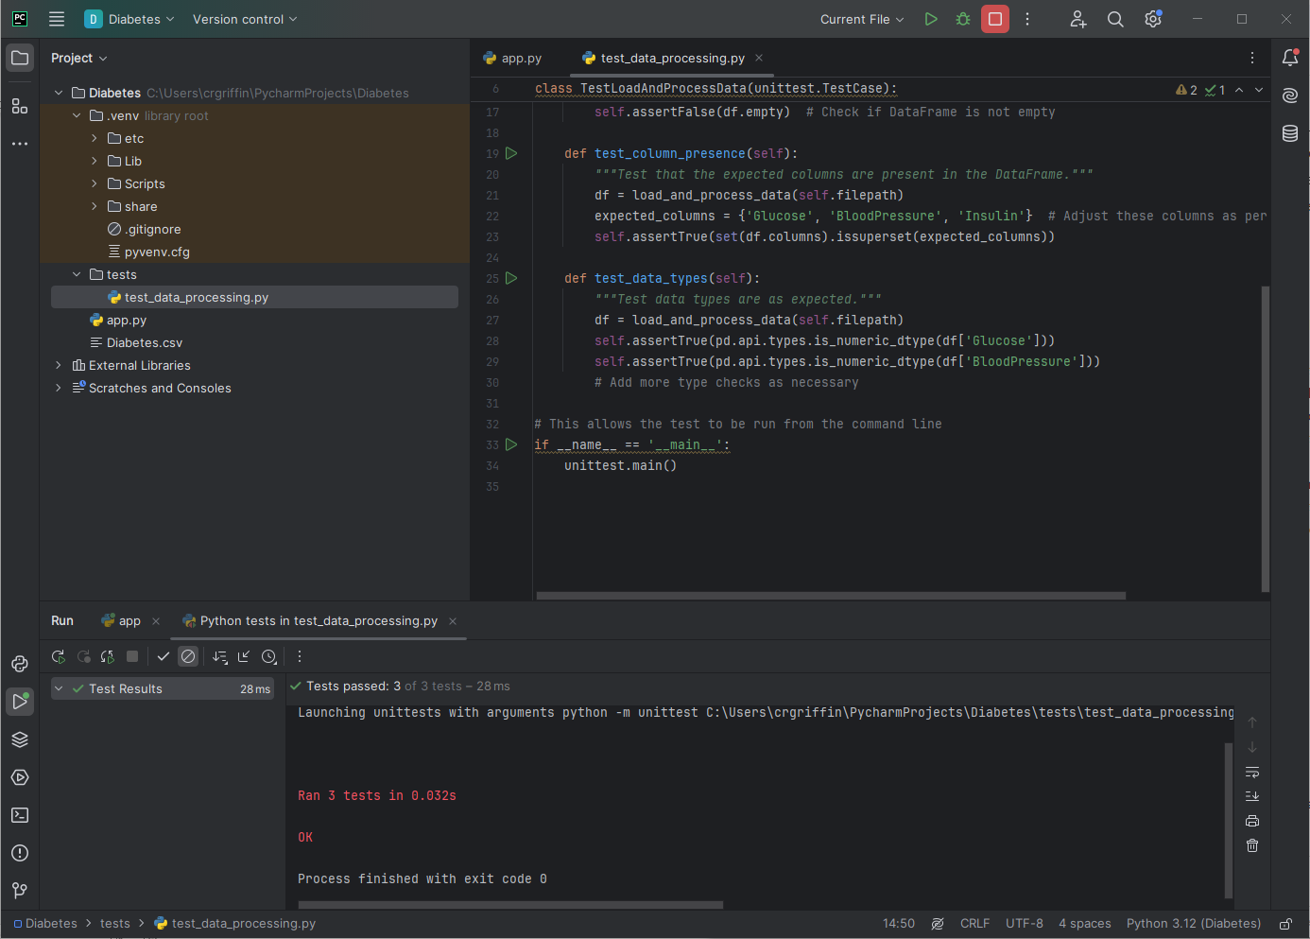

* All Tests Passed: The output indicating "OK" and the message "Ran 3 tests in 0.032s" means all specified tests were executed and passed successfully without any assertions failing.
  + Correctness of Data Loading: The successful execution of test_data_loading implies that the function correctly loads data into a DataFrame, which is not empty, confirming the file's readability and basic integrity.
  + Column Presence: The successful execution of test_column_presence confirms that the required columns are present in the DataFrame, which is vital for any feature that depends on these columns.
  + Data Types: The successful execution of test_data_types ensures that the data in critical columns is of the expected type, which is crucial for processing or analysis tasks that assume specific data types.

Significance of the Outcomes

* Reliability: Passing these tests increases confidence in the reliability of the data loading and processing functions of my application. It ensures that foundational data handling, which many other features may rely on, performs as expected.
* Regression Safety: These tests serve as a regression suite that can be rerun every time the codebase changes. If future modifications break the functionality that these tests cover, it will be immediately apparent.
* Maintenance and Debugging: Having these tests in place makes the system easier to maintain and debug. If a test fails, it provides a specific point of failure that can be addressed, rather than having to diagnose an issue from the symptoms in a more complex operational environment.

**Integration Testing**

This tests the interaction between different parts of the application, such as data flows from file upload to data processing and visualization generation. The integration testing for my data product application was conducted using the Python unittest framework in conjunction with Selenium WebDriver, specifically the Edge version. Selenium automates browser actions to simulate user interactions in a real-world scenario. Here’s a brief overview of how the test was structured:

1. Setup Method:
   1. WebDriver Configuration: Initializes the Edge WebDriver using Selenium, setting it to headless mode (browser runs in the background without a GUI).
   2. Navigating to the App: The driver loads the Dash app by navigating to its URL.
2. Test Method (test_file_upload):
   1. Interaction: Uses WebDriver to simulate clicking the 'Select Files' button on the webpage.
   2. File Selection: Because Selenium cannot interact directly with file dialogs (these are outside the browser's control), PyAutoGUI is used to simulate typing the file path and pressing 'Enter' to upload a file. This is where I am running into a failed test and need to figure out how to debug.
   3. Verification: Waits for the visualization element to appear as a result of the file upload, verifying that the expected output is displayed.
3. Teardown Method:
   1. Closes the browser and quits the WebDriver to clean up after tests.

Job Failing - Needs Debugging:

Despite my app working as intended with my own hand, the test job is failing, indicating issues that require debugging. Here’s a concise outline of potential problems and debugging steps:

1. File Dialog Interaction: The use of PyAutoGUI to handle file dialogs is error-prone and heavily dependent on the system's response time and state. Any delays or unexpected behaviors in the GUI can cause this step to fail.
2. Headless Mode Limitations: Running the browser in headless mode can sometimes behave differently than a non-headless mode, especially with complex interactions like file uploads or JavaScript execution.
3. Synchronization Issues: The waits and timeouts might not be adequately configured, or dynamic content (like visualizations that load after data processing) might not appear within the expected timeframe.
4. Network or Service Issues: If the Dash app is not running or there are network issues when the test tries to access the app, the test will fail.

**Test User Engagement**

Testing user interactions with the application, such as button clicks and form submissions, can be conducted using Selenium or Dash Testing tools which extend Selenium.

1. Setup and Initialization:
   1. Edge WebDriver: The script uses Selenium with the Edge WebDriver, set up and managed via EdgeChromiumDriverManager. This ensures compatibility with the latest versions of Microsoft Edge.
   2. Driver Configuration: The WebDriver starts and navigates to the local URL of the Dash app (http://localhost:8050).
2. Interactive Testing:
   1. File Upload: The script waits until the file input is visible and then simulates a user uploading a file by specifying the path to Diabetes.csv and setting it in the upload component.
   2. Button Interaction: After uploading the file, it waits for the 'Evaluate' button to be clickable and then simulates a click. This part tests the application's response to user inputs that trigger backend processes.
3. Result Verification:
   1. Output Validation: The script waits to see if a specific outcome, like a success message or data display, is visible after the interactions. It asserts that the expected result appears, confirming that the application behaves as intended.

Issue

1. Element Timing and Visibility:
   1. Element Access Delays: Elements may not be immediately visible or interactable, particularly if the application performs background processing or rendering based on the uploaded file.
   2. Incorrect Selectors: If the application's frontend code is updated, CSS selectors or element IDs used in the script may no longer correspond, leading to failures in locating these elements.
2. File Path Input Restrictions:
   1. Security Restrictions: Some browsers have security settings that prevent automated scripts from interacting with file input elements, which can block the upload process.
3. Environmental Variability:
   1. Server Issues: If the local Dash server isn’t running or there are issues with its configuration, the WebDriver cannot load the application, causing the test to fail. This is my main issue currently.
   2. Browser-Driver Compatibility: Ensure that the Edge WebDriver is compatible with the installed version of Edge. Incompatibilities can cause unexpected behavior.

Debugging Steps

* Check and Update Element Selectors: Make sure that the CSS selectors and IDs match those currently used in the application.
* Enhance Wait Conditions: Increase the timeout values or adjust conditions within WebDriverWait to better accommodate slower operations, especially following file uploads.
* Run in Visible Mode: Temporarily disable headless mode if used, to visually verify the interactions and better understand where the process might be failing.
* Review Logs: Check browser and Selenium logs for errors or warnings that might indicate what went wrong during test execution.

**Test Results and Test Visual Reports**

In my data product, there is also significant potential for expanding the testing framework to include results tesing and visual reports testing (tricky one), though I have not implemented these yet due to issues with other tesings.

1. Results Testing:
   1. This would involve validating the correctness and accuracy of the data processing and analysis outputs my product generates.
   2. For instance, after uploading a dataset and performing operations like statistical analysis or machine learning model evaluations, I could automate tests to verify that the outputs (e.g., accuracy scores, predictive results) are as expected based on known test data.
   3. This ensures that my data product not only functions as intended from a user interaction perspective but also delivers reliable analytical results.
2. Visual Reports Testing:
   1. Given that my data product generates visual outputs or reports (for instance, charts, graphs, or downloadable files), testing these visual aspects would ensure that the reports are generated correctly and contain accurate information.
   2. This could involve checking that charts display the correct data points, visualizations appear as expected, or PDF reports are formatted correctly.
   3. Visual report testing could help in catching errors in data visualization logic or export functionalities that might not be apparent through manual inspection alone.